Bucket: CPT-CICD-AZURE
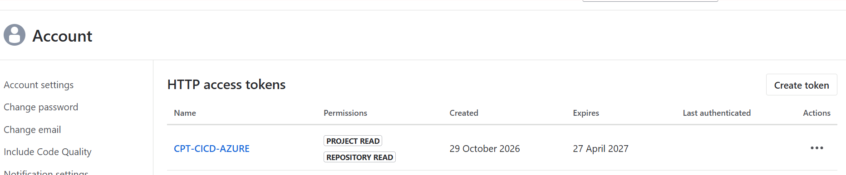

Token: BBDC-OTc4NTE3MjkyMjcyOuRmrKr+kfYCF2HCcGhBfD1HiBst

Deploy a CAP Business Service to SAP Business Technology Platform
https://developers.sap.com/tutorials/cap-service-deploy/

Cloud Foundry CLI
https://github.com/cloudfoundry/cli#downloads

Cloud MTA Build Tool
https://sap.github.io/cloud-mta-build-tool/download/

MultiApps CF CLI Plugin
https://github.com/cloudfoundry/multiapps-cli-plugin/blob/master/README.md

CAP: Configuration Profiles
https://cap.cloud.sap/docs/node.js/cds-env#profiles

Deploy to Cloud Foundry
https://cap.cloud.sap/docs/guides/deploy/to-cf

Deploy using CI/CD Pipelines
https://cap.cloud.sap/docs/guides/deploy/cicd

GitHub - Continuous integration
https://docs.github.com/en/actions/get-started/continuous-integration

Build a CI/CD Pipeline in Azure DevOps and connect it to SAP Cloud Foundry
https://community.sap.com/t5/devops-and-system-administration-blog-posts/build-a-ci-cd-pipeline-in-azure-devops-and-connect-it-to-sap-cloud-foundry/ba-p/13478893

